  
3 Humabon Place, Magallanes Makati City

Aruga at Kalinga Foundation Inc.  
Crowd Funding Site

Project Document Submitted

To the faculty of School of Computing and  
 Information Technologies of

**ASIA PACIFIC COLLEGE**

**Submitted by:**

Mortera, Jorome  
Malapo, Abigail  
Go, Jovin

**Table of Content**

Introduction . . . . . . . . . . . . . . . . . . . . . . . . . . . . . . . . . . . . . . . . . . . . . . . . . . . . . . . . . . . . . . . 3  
Project Context . . . . . . . . . . . . . . . . . . . . . . . . . . . . . . . . . . . . . . . . . . . . . . . . . . . . . . . . . . . 3  
Purpose and Description. . . . . . . . . . . . . . . . . . . . . . . . . . . . . . . . . . . . . . . . . . . . . . . . . . 3  
Objectives. . . . . . . . . . . . . . . . . . . . . . . . . . . . . . . . . . . . . . . . . . . . . . . . . . . . . . . . . . . . . . . . 3  
Scope and Limitations . . . . . . . . . . . . . . . . . . . . . . . . . . . . . . . . . . . . . . . . . . . . . . . . . . . . 3  
List of Figures, Tables & Notations . . . . . . . . . . . . . . . . . . . . . . . . . . . . . . . . . . . . . . . . . . 4  
Event Table . . . . . . . . . . . . . . . . . . . . . . . . . . . . . . . . . . . . . . . . . . . . . . . . . . . . . . . . . . . . . . . 4  
Use Case Diagram . . . . . . . . . . . . . . . . . . . . . . . . . . . . . . . . . . . . . . . . . . . . . . . . . . . . . . . . . 5  
Use Case Full Description . . . . . . . . . . . . . . . . . . . . . . . . . . . . . . . . . . . . . . . . . . . . . . 6 - 9  
Context Flow . . . . . . . . . . . . . . . . . . . . . . . . . . . . . . . . . . . . . . . . . . . . . . . . . . . . . . . . . . . . . 9  
Class Diagram . . . . . . . . . . . . . . . . . . . . . . . . . . . . . . . . . . . . . . . . . . . . . . . . . . . . . . . . . . . . 10  
Object Diagram . . . . . . . . . . . . . . . . . . . . . . . . . . . . . . . . . . . . . . . . . . . . . . . . . . . . . . . . . . . 10  
Entity Relationship Diagram . . . . . . . . . . . . . . . . . . . . . . . . . . . . . . . . . . . . . . . . . . . . . . 11  
Data Flow Diagram . . . . . . . . . . . . . . . . . . . . . . . . . . . . . . . . . . . . . . . . . . . . . . . . . . . . . . . 12  
Activity Diagram . . . . . . . . . . . . . . . . . . . . . . . . . . . . . . . . . . . . . . . . . . . . . . . . . . . . . . . . . 12  
Sequence Diagram . . . . . . . . . . . . . . . . . . . . . . . . . . . . . . . . . . . . . . . . . . . . . . . . . . . . . . 13

1. **INTRODUCTION**

**1.1 Project Context**

Aruga at Kalinga Foundation Inc. is a group of people who were aiming for a million dollars to help their beneficiaries, like giving scholars, feeding the street children, helping the poor and many more. The charity wants to build a house for them to stay and live. Children and oldies from the street who doesn’t have permanent place to stay, they will adopt and support all their needs like sending children to school, feeding them, giving clothes and give them a place to stay. For the students who are eager to learn and study but they don’t have enough money to support their studies a scholarship will be given.

* 1. **Purpose and Description**

For the charity to gain their goal, they want to create a website wherein all the activities, needs, and the online donation will be found so that the person who is a far and willing to donate will have an easy access thru it. And so our client wants our group to create a crowd funding site.

* 1. **Objectives**

The main objective of this project is to build a website that can advertise the foundation’s campaign, display progress of every activity, easiest way of donating and a regular update of the system for transparency of funds.

* 1. **Scope and Limitations**

The purpose of this project is to help them to establish the Aruga and Kalinga Foundation Inc. by creating a crowd funding site thru online donation. All donations will be used for helping people in needs.

1. **List of Figures, Tables & Notations**

**2.1 Event Table**

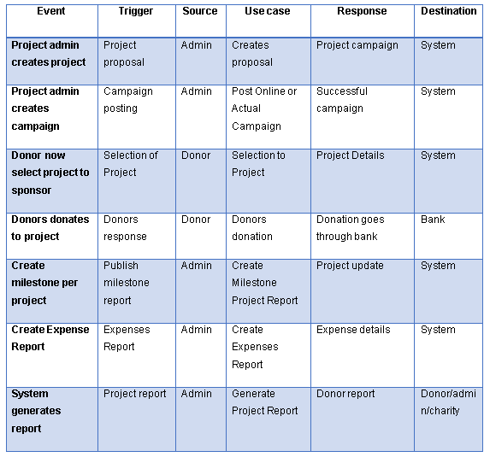

**2.2 Use Case Diagram**

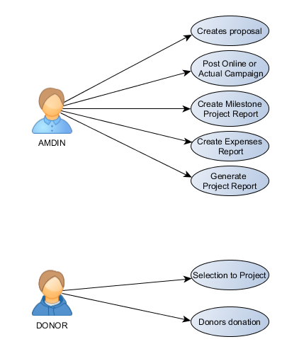

* 1. **Use Case Full description**

|  |  |
| --- | --- |
| Use Case: | Creates proposal |
| Scenario: | Creating and planning a project proposal |
| Triggering Events: | Project proposal |
| Actor: | Admin |
| Related Use Case: |  |
| Stakeholders: | Admin |
| Pre-Conditions: | There must be a subject for a project |
| Post-Conditions: |  |
| Flow of Events: | |  |  | | --- | --- | | Actor | System | | 1.Project admin will gather information for the project  2. The project admin will propose a project  3. Other admins will make decision if it’s okay  4. Post it in website | 4.1 The Website will display the project | |
| Except Conditions: | The project may not proceed if the admin disapproves the proposal |

|  |  |
| --- | --- |
| Use Case: | Post Online or Actual Campaign |
| Scenario: | Advertising by social media and giving flyers |
| Triggering Events: | Campaign posting |
| Actor: | Admin |
| Related Use Case: |  |
| Stakeholders: | Admin/Donor |
| Pre-Conditions: | A person that is willing to spend a day posting it in websites. |
| Post-Conditions: |  |
| Flow of Events: | |  |  | | --- | --- | | Actor | System | | 1. video clip advertising  2. giving flyers  3. posting our project in street  4. social website campaign | 1.1 The Website will display the video clips  4.1 The website will be linked in social media sites | |
| Except Conditions: |  |

|  |  |
| --- | --- |
| Use Case: | Selection to Project |
| Scenario: | Donating money, supplies and even services. |
| Triggering Events: | Donors response |
| Actor: | Donor |
| Related Use Case: |  |
| Stakeholders: | Donor/Admin |
| Pre-Conditions: | A person that is willing to help is a must |
| Post-Conditions: |  |
| Flow of Events: | |  |  | | --- | --- | | Actor | System | | 1. visits the website  2. browse project gallery  3. reading the project description  4. ask the admins for further information about the project | 2.1 the website will show the video clips and pictures about the project  3.1 this explains who/what will be the projects subject, mission and vision | |
| Except Conditions: | We do not force anyone to donate |

|  |  |
| --- | --- |
| Use Case: | Donors donation |
| Scenario: | Building what the project is all about. |
| Triggering Events: | Proceed to project |
| Actor: | Admin |
| Related Use Case: |  |
| Stakeholders: | Donor |
| Pre-Conditions: | Depends on amount of donation receive |
| Post-Conditions: |  |
| Flow of Events: | |  |  | | --- | --- | | Actor | System | | 1. click the donate button  2. fill up the donation form  3. check the important information  4. select the what to donate  5. donate | 1.1 the website will direct to the donation form  2.1 will display the full information details of the donor  4.1 will prompt the donor to contact the admin | |
| Except Conditions: |  |

|  |  |
| --- | --- |
| Use Case: | Create Milestone Project Report |
| Scenario: | Showing the project progress for donors to see where the donations go. |
| Triggering Events: | Accomplishment report |
| Actor: | Admin |
| Related Use Case: |  |
| Stakeholders: | Admin |
| Pre-Conditions: | Create Expenses Report |
| Post-Conditions: | The project will proceed |
| Flow of Events: | |  |  | | --- | --- | | Actor | System | | 1. taking pictures about the project  2. showing the project documentation  3. video clip in gallery | 1.1 the website will display the projects milestones  2.1 will display the full information when it was started and the current situation  3.1 will display the video summary of the undergoing project | |
| Except Conditions: | The project may not proceed if the admin did not meet the defined project milestone. |

|  |  |
| --- | --- |
| Use Case: | Create Expenses Report |
| Scenario: | Showing the donations did take place. |
| Triggering Events: | Money spreading report |
| Actor: | Admin |
| Related Use Case: | Profile of the project |
| Stakeholders: | Admin |
| Pre-Conditions: |  |
| Post-Conditions: |  |
| Flow of Events: | |  |  | | --- | --- | | Actor | System | | 1. computes all the expenses  2. shows where the donations take place  3. summary of all expenses | 3.1 the website will the display the summary of all expenses paid for the project | |
| Except Conditions: |  |

|  |  |
| --- | --- |
| Use Case: | Generate Project Report |
| Scenario: | Showing the donations did take place. |
| Triggering Events: | Money spreading report |
| Actor: | Admin |
| Related Use Case: | Profile of the project |
| Stakeholders: | Admin |
| Pre-Conditions: |  |
| Post-Conditions: |  |
| Flow of Events: | |  |  | | --- | --- | | Actor | System | | 1. computes the total cost  2. creates a summary of the whole project | 1.1 displays the cost of the project  2.1 displays the whole project status to show where the donations go | |
| Except Conditions: |  |

* 1. **Context Flow Diagram**

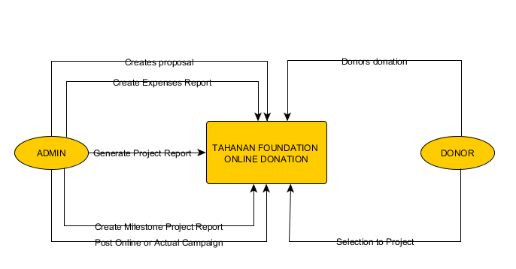

* 1. **Class Diagram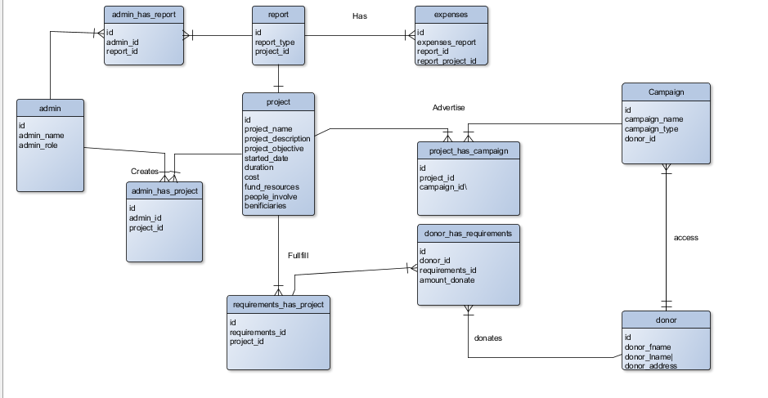 2.6 Object Diagram**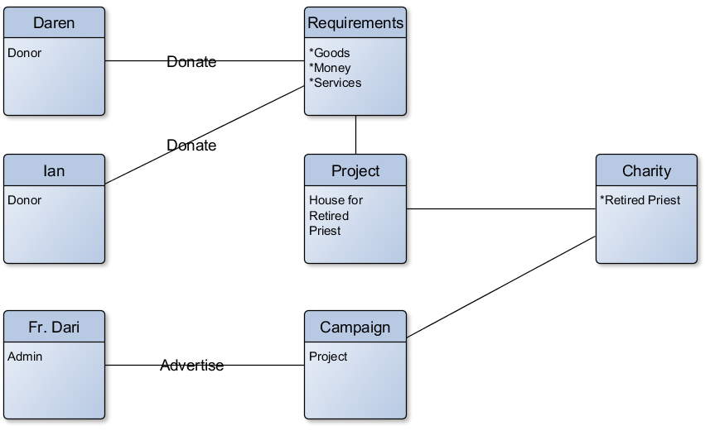
  2. **Entity Relationship Diagram**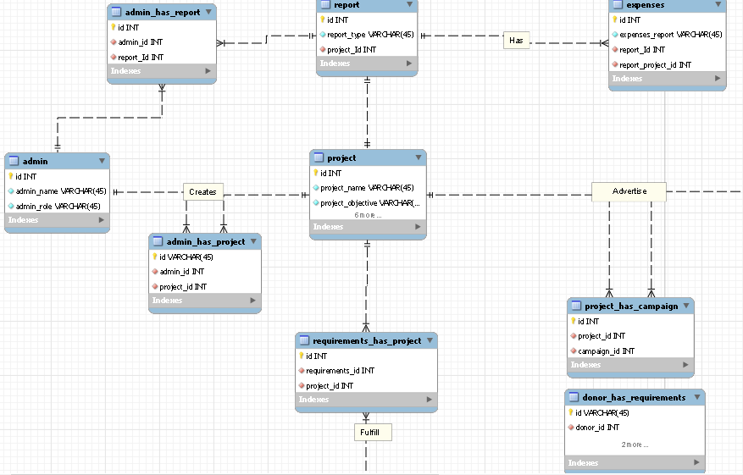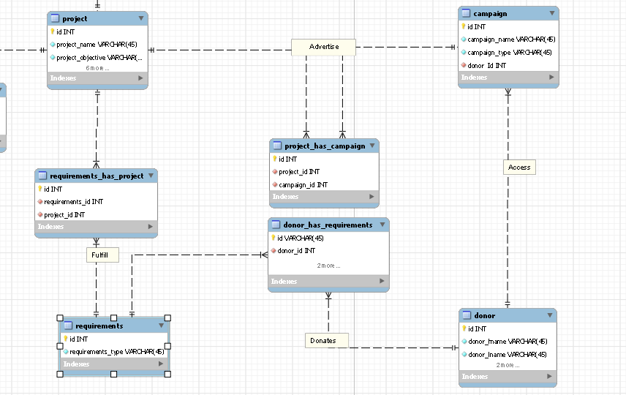
  3. **Data Flow Diagram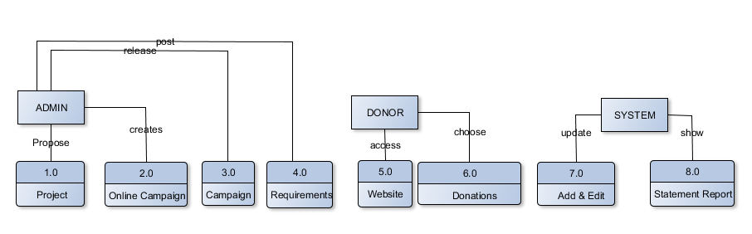 2.9 Activity Diagram**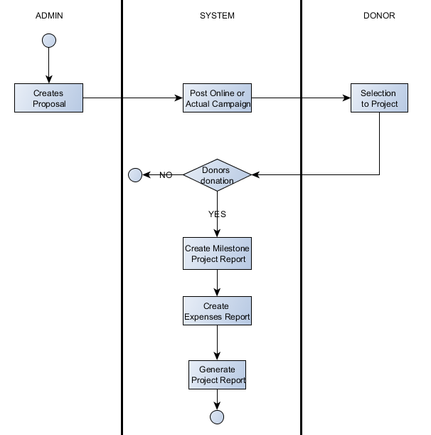
  4. **Sequence Diagram**

